Chapter 27 Electrical
CALIFORNIA BUILDING CODE — MATRIX ADOPTION TABLE
CHAPTER 27 — ELECTRICAL
(Matrix Adoption Tables are nonregulatory, intended only as an aid to the code user.
See Chapter 1 for state agency authority and building applications.)
Adopting agency | BSC | BSC-  CG | SFM | HCD |  |  | DSA |  |  | OSHPD |  |  |  |  |  |  | BSCC | DPH | AGR | DWR | CEC | CA | SL | SLC
 |  |  |  | 1 | 2 | 1/AC | AC | SS | SS/CC | 1 | 1R | 2 | 3 | 4 | 5 | 6
Adopt entire chapter
Adopt entire chapter as  amended (amended sections listed below) |  |  | X
Adopt only those sections
that are listed below
Chapter / Section
2702.1.2 |  |  | X
2702.2.11 |  |  | X
2702.2.13 |  |  | X
The state agency does not adopt sections identified with the following symbol: †
The Office of the State Fire Marshal's adoption of this chapter or individual sections is applicable to structures regulated by other state agencies pursuant to Section 1.11.
User notes:
About this chapter: Electrical systems and components are integral to most structures; therefore, it is necessary for the code to address their installation and protection. Structures depend on electricity for the operation of many life safety systems including fire alarm, smoke control and exhaust, fire suppression, fire command and communication systems. Since power supply to these systems is essential, Chapter 27 addresses where standby and emergency power must be provided.
ICC code development note: Code change proposals to sections preceded by the designation [F] will be considered by the IFC code development committee meeting during the 2024 (Group A) Code Development Cycle. All other code change proposals will be considered by a code development committee meeting during the 2025 (Group B) Code Development Cycle.
Section 2701 General
2701.1 Scope
Diagram
The provisions of this chapter and the California Electrical Code shall govern the design, construction, erection and installation of the electrical components, appliances, equipment and systems used in buildings and structures covered by this code. The California Fire Code, the International Property Maintenance Code and the California Electrical Code shall govern the use and maintenance of electrical components, appliances, equipment and systems. The California Existing Building Code and the California Electrical Code shall govern the alteration, repair, relocation, replacement and addition of electrical components, appliances, or equipment and systems.
UpCodes Diagrams (27)
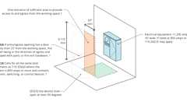
Elect. Equip.: Entrance/Egress from Working Space, pt. 1
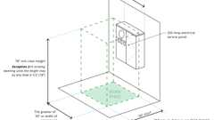
Electrical Panel - Work Space Height
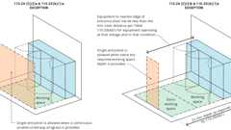
Elect. Equip.: Entrance/Egress from Working Space, pt. 3
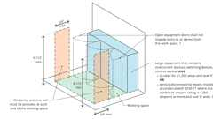
Elect. Equip.: Entrance/Egress from Working Space, pt. 2
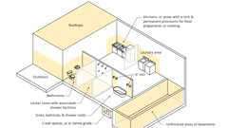
GFCI locations - Other than Dwellings
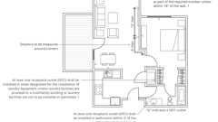
Receptacles: Dwelling Units
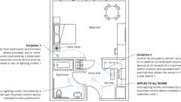
Lighting Outlets - Guest Rooms / Suites
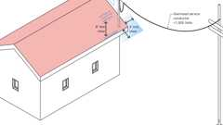
Overhead Service Conductors: Above Roofs (< 1000V)
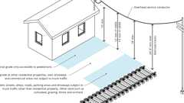
Overhead Service Conductors: Vertical Clearance (< 1000V)
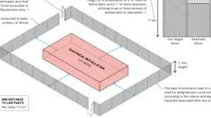
Enclosures for Outdoor Electrical Installations (≥1000V)
Show 17 more
Building products (3)
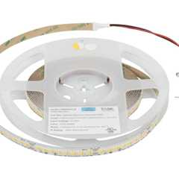
16 Ft, 400 Lumens/Ft. 24-volt High Output LED Tape Light, Tunable-White, 2700K–5000K - LT400W24V016-TW
Task Lighting and Power

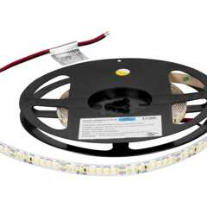
16 Ft, 600 Lumens/Ft. 24-volt Higher Output LED Tape Light, Single-White - LS600W24V016
Task Lighting and Power

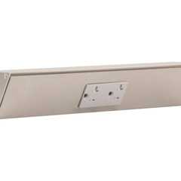
TR Series Angle Power Strip - TR
Task Lighting and Power

Section 2702 Emergency and Standby Power Systems
Diagram
UpCodes Diagrams (2)
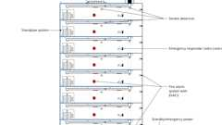
High Rise: Emergency Systems
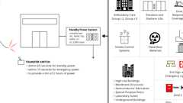
Standby Power Systems
[F] 2702.1 General
Emergency power systems and standby power systems shall comply with Sections 2702.1.1 through 2702.1.8.
[F] 2702.1.1 Stationary Generators
Stationary emergency and standby power generators required by this code shall be listed in accordance with UL 2200.
[F] 2702.1.2 Fuel-Line Piping Protection
Fuel lines supplying a generator set inside a high-rise building or new Group I-2 occupancy having occupied floors located more than 75 feet (23 m) above the lowest level of fire department vehicle access shall be separated from areas of the building other than the room the generator is located in by one of the following methods:
- A fire-resistant pipe-protection system that has been tested in accordance with UL 1489. The system shall be installed as tested and in accordance with the manufacturer's installation instructions, and shall have a rating of not less than 2 hours. Where the building is protected throughout with an automatic sprinkler system installed in accordance with Section 903.3.1.1, the required rating shall be reduced to 1 hour.
- An assembly that has a fire-resistance rating of not less than 2 hours. Where the building is protected throughout with an automatic sprinkler system installed in accordance with Section 903.3.1.1, the required fire-resistance rating shall be reduced to 1 hour.
- Other approved methods.
[F] 2702.1.3 Installation
Emergency power systems and standby power systems required by this code or the California Fire Code shall be installed in accordance with the California Fire Code, the California Electrical Code, NFPA 110 and NFPA 111.
[F] 2702.1.4 Load Transfer
Emergency power systems shall automatically provide secondary power within 10 seconds after primary power is lost, unless specified otherwise in this code. Standby power systems shall automatically provide secondary power within 60 seconds after primary power is lost, unless specified otherwise in this code.
[F] 2702.1.5 Load Duration
Emergency power systems and standby power systems shall be designed to provide the required power for a minimum duration of 2 hours without being refueled or recharged, unless specified otherwise in this code.
[F] 2702.1.6 Uninterruptable Power Source
An uninterrupted source of power shall be provided for equipment where required by the manufacturer's instructions, the listing, this code or applicable referenced standards.
[F] 2702.1.7 Interchangeability
Emergency power systems shall be an acceptable alternative for installations that require standby power systems.
[F] 2702.1.8 Group I-2 Occupancies
In Group I-2 occupancies located in flood hazard areas established in Section 1612.3, where new essential electrical systems are installed, and where new essential electrical system generators are installed, the systems and generators shall be located and installed in accordance with ASCE 24. Where connections for hookup of temporary generators are provided, the connections shall be located at or above the elevation required in ASCE 24.
[F] 2702.2 Where Required
Emergency and standby power systems shall be provided where required by Sections 2702.2.1 through 2702.2.19.
[F] 2702.2.1 Ambulatory Care Facilities
Essential electrical systems for ambulatory care facilities shall comply with Section 422.6.
[F] 2702.2.2 Elevators and Platform Lifts
Diagram
Standby power shall be provided for elevators and platform lifts as required in Sections 1009.4.1, 1009.5, 3003.1, 3007.8 and 3008.8.
UpCodes Diagrams (3)
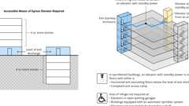
Access. Means of Egress: Elevators
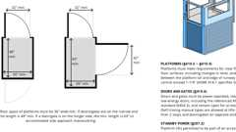
Vertical Platform Lifts
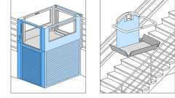
Platform Lift Types
[F] 2702.2.3 Emergency Responder Communication Coverage Systems
Diagram
Standby power shall be provided for in-building 2-way emergency responder communication coverage systems required in Section 918 and the California Fire Code. The standby power supply shall be capable of operating the in-building 2-way emergency responder communication coverage system at 100-percent system operation capacity for a duration of not less than 12 hours.
UpCodes Diagram (1)
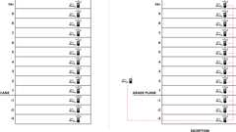
Emergency Responder Radio Coverage (New Bldgs.)
[F] 2702.2.4 Emergency Voice/Alarm Communication Systems
Standby power shall be provided for emergency voice/alarm communication systems in accordance with NFPA 72.
[F] 2702.2.5 Exhaust Systems
Diagram
Standby power shall be provided for common exhaust systems for domestic kitchens located in multistory structures as required in Section 505.5 of the California Mechanical Code. Standby power shall be provided for common exhaust systems for clothes dryers located in multistory structures as required in Section 504.11 of the California Mechanical Code and Section 614.11 of the International Fuel Gas Code.
UpCodes Diagram (1)
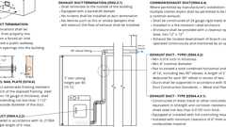
Clothes Dryer Exhaust (CA)
[F] 2702.2.6 Exit Signs
Diagram
Emergency power shall be provided for exit signs as required in Section 1013.6.3. The system shall be capable of powering the required load for a duration of not less than 90 minutes.
UpCodes Diagrams (3)
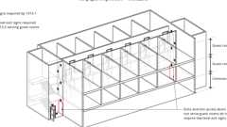
Exit Signs in R-1 Occupancies
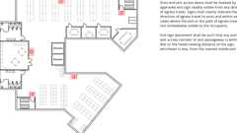
Exit Signs: Where Required
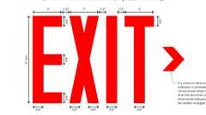
Exit Signs: Size Requirements
[F] 2702.2.7 Gas Detection System
Emergency or standby power shall be provided for gas detection systems in accordance with the California Fire Code.
[F] 2702.2.8 Group I-2 Occupancies
Essential electrical systems for Group I-2 occupancies shall be in accordance with Section 407.11.
[F] 2702.2.9 Group I-3 Occupancies
Emergency power shall be provided for power-operated doors and locks in Group I-3 occupancies as required in Section 408.4.2.
[F] 2702.2.10 Hazardous Materials
Emergency or standby power shall be provided in occupancies with hazardous materials where required by the California Fire Code.
[F] 2702.2.11 High-Rise Buildings and Group I-2 Occupancies Having Occupied Floors Located More Than 75 Feet Above the Lowest Level of Fire Department Vehicle Access
Emergency and standby power shall be provided in high-rise buildings and Group I-2 occupancies having occupied floors located more than 75 feet above the lowest level of fire department vehicle access as required in Section 403.4.8.
[F] 2702.2.12 Hydrogen Fuel Gas Rooms
Standby power shall be provided for hydrogen fuel gas rooms as required by the California Fire Code.
2702.2.13 Group L Occupancy
Secondary power shall be provided in Group L occupancies in accordance with this chapter and Section 453.4.6 and 453.4.6.1.
[F] 2702.2.14 Means of Egress Illumination
Diagram
Emergency power shall be provided for means of egress illumination as required in Section 1008.3. The system shall be capable of powering the required load for a duration of not less than 90 minutes.
UpCodes Diagram (1)
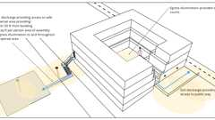
Means of Egress Illumination: Exit Discharge
[F] 2702.2.15 Membrane Structures
Standby power shall be provided for auxiliary inflation systems in permanent membrane structures as required in Section 3102.8.2. Standby power shall be provided for a duration of not less than 4 hours. Auxiliary inflation systems in temporary air-supported and air-inflated membrane structures shall be provided in accordance with Section 3103.9.4 of the California Fire Code.
[F] 2702.2.16 Semiconductor Fabrication Facilities
Emergency power shall be provided for semiconductor fabrication facilities as required in Section 415.11.11.
[F] 2702.2.17 Smoke Control Systems
Standby power shall be provided for smoke control systems as required in Sections 404.7, 909.11, 909.20.7.2 and 909.21.5.
[F] 2702.2.18 Special Purpose Horizontal Sliding, Accordion or Folding Doors
Standby power shall be provided for special purpose horizontal sliding, accordion or folding doors as required in Section 1010.3.3. The standby power supply shall have a capacity to operate not fewer than 50 closing cycles of the door.
[F] 2702.2.19 Underground Buildings
Emergency and standby power shall be provided in underground buildings as required in Section 405.
[F] 2702.3 Critical Circuits
Assembly
Required critical circuits shall be protected using one of the following methods:
- Cables, used for survivability of required critical circuits, that are listed in accordance with UL 2196 and have a fire-resistance rating of not less than 1 hour.
- Electrical circuit protective systems having a fire-resistance rating of not less than 1 hour. Electrical circuit protective systems are installed in accordance with their listing requirements.
- Construction having a fire-resistance rating of not less than 1 hour.
Assembly (1)
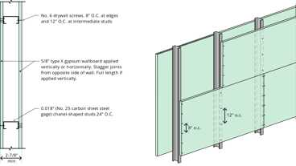
13-1.1: 1hr Steel Studs
[F] 2702.4 Maintenance
Emergency and standby power systems shall be maintained and tested in accordance with the California Fire Code.
Section 2703 Lightning Protection Systems
2703.1 General
Where provided, lightning protection systems shall comply with Sections 2703.2 through 2703.3.
2703.2 Installation
Lightning protection systems shall be installed in accordance with NFPA 780 or UL 96A. UL 96A shall not be utilized for buildings used for the production, handling or storage of ammunition, explosives, flammable liquids, flammable gases or other explosive ingredients including dust.
2703.2.1 Surge Protection
Where lightning protection systems are installed, surge protective devices shall also be installed in accordance with the California Electrical Code and either NFPA 780 or UL 96A, as applicable.
2703.3 Interconnection of Systems
All lightning protection systems on a building or structure shall be interconnected in accordance with NFPA 780 or UL 96A, as applicable.

